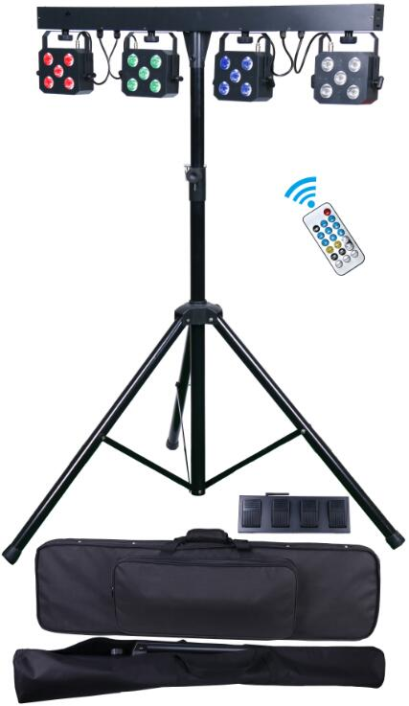

USER MANUAL

Please keep the manual carefully for future reference
Contents

Introduction & Caution--------------------------------------------P2

Silkscreen and safety instructions ---------------------------P3

Installation instruction---------------------------------------------P5

Product specification/MENU Operation----------------------P6

Remote control--------------------------------------------------------P7

Wireless foot controller/DMX512 table-----------------------P8

DMX connection-----------------------------------------------------P9

DMX address setting ----------------------------------------------P10

Clearing and Maintenance--------------------------------------P10

Introduction
Thank you for your patronage. We are confident that our excellent products and service can satisfy you. For your own safety, please read this user manual carefully before installing the device.
In order to install , operate, and maintain the lighting safety and correctly. We suggest that the installation and operation should be done by the verified technician and follow the instruction strictly.

Following spare parts are included with the fixture:
- One light
- One T-stand
- One wireless foot controller
- One remote controller
- One use manual
- One power cable
Caution
Before leaving the factory, this device has passed strict inspection, functions stable and perfect packing. If this device operates in any way different to the one described in this manual, the product may suffer damages and the guarantee becomes void. Furthermore, any other operation may lead to dangers like short circuit, burns, electric shock, crash etc.



CAUTION!

Keep this device away from rain and moisture!

Unplug mains lead before opening the housing!


Warning!

Damages caused by the disregard of this user manual are not subject to warranty. The dealer will not accept liability for any resulting defects or problems.

Symbol Instruction On The Device
………………………………………..…………… CE Compliant

…

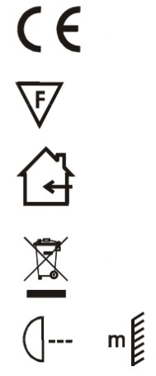
…Suitable directly installed on the common combustible materials devices

…

……………………………..………………………Only indoor use

…

……………………………………………Environmental protection
……

…

…...The minimum distance from fixture to the lighted objects(meter)

…

- Safety Instructions

CAUTION!

Be careful with your operations. With a dangerous voltage you will
suffer a dangerous electric shock when touching wires!
This device has left the factory in perfect condition. In order to maintain this condition and to ensure a safe operation, it is absolutely necessary for the user to follow the safety instructions and warning notes written in this user manual.
►If the device has been exposed to temperature changes due to environmental changes, do not switch it on immediately. The arising condensation could damage the device. Leave the device switched off until it has reached room temperature.
►Please make sure that the device be earthed.
►Please replace housing if it is broken. This fixture can be used after finished installed.
►The electric connection must carry out by qualified person.
►Make sure that the available voltage is not higher than stated at the end of this manual.
►Make sure the power cord is never crimped or damaged by sharp edges. If this would be the case, replacement of the cable must be done by an authorized dealer.
►If the external flexible cable or cord of this fixture is damaged, it shall be exclusively replaced by the manufacturer or his service agent or a similar qualified person in order to avoid a hazard.
►Please turn off the fixture if don't use in the fixture or want to clean, maintenance.
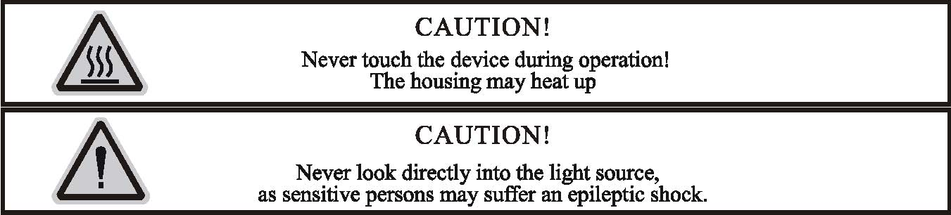
Please be aware that damages caused by manual modifications to the device are not subject to warranty. Keep away from non-professionals.
General Guidelines
►This device is a lighting effect for professional use on stages, in discotheques, theaters, etc., the device was designed for indoor use only.
►This fixture is only allowed to be operated with the max alternating current which stated in the technical specifications in the last page of this manual.
►The device can work continuously for eight hours. Lighting effects are not designed for permanent operation. Consistent operation breaks may ensure that the device will serve you for a long time without defects.
►Handle with care, do not make the device by strong shocks.
►While choosing the installation-spot, please make sure that the device is not exposed to extreme heat, moisture or dust. Please don't project the beam onto combustible substances.The minimum distance between light-output from the projector and the illuminated surface must be more than 1 meter.
►Please do not in damp, overheat or dusty environment install and use the device. Do not use light on fuel. The distance between the device and the projectile to keep at least 1 meter.
►If you use the quick lock cam in hanging up the fixture, please make sure the quick lock fasteners turned in the quick lock holes correctly,and add safety rope.
►Operate the device only after having familiarized with its functions. Do not permit operation by persons not qualified for operating the device. Most damages are the result of unprofessional operation.
►Please use the original packaging if the device is to be transported.
►For safety reasons, please be aware that all modifications on the device are forbidden.
►Any installation and maintenance must by professional person.
►If this device will be operated in any way different to the one described in this manual, the product may suffer damages and the guarantee becomes void. Furthermore, any other operation may lead to short-circuit, burns, electric shock, lamp explosion, crash, etc.

- Installation instruction
CAUTION!
Please consider the GB7000.15/EN60598-2-17 and the other respective national norms during
The installation. The installation must only be carried out by a qualified person.


►The applicable temperature for the lighting is between -25°C to 45°C. Do not use the lighting under or above the temperature.
►The installation of the effect has to be built and constructed in a way that it can hold 10 times the weight for 1 hour without any harming deformation.
►The installation must always be secured with a secondary safety attachment, e.g. an appropriate safety rope.Never stand directly below the device when mounting, removing or servicing the fixture.
►The operator has to make sure the safety relating and machine technical installations are approved
by an expert before taking the device into operation for the first time.
►These installations have to be approved by a skilled person once a year.
►Overhead mounting requires extensive experience, including among others
calculating working load limits, installation material being used, and periodic safety inspection of all installation material and the device. If you lack these qualifications, do not attempt the installation yourself. Improper installation can result in bodily injury.
3. Specification of the Device
4pcs 5*10W RGBW 4in1 LED with average 50000 hours lifespan; beam angle：15º；
- pins XLR
Each par bar can separately control
Single par can at 3m (light spot is 1.1m): Red: 210lux/Green: 590lux/
Blue: 70lux/ White: 480lux/ RGBW:690lux
4pcs par can full on at 3m(light spot is 2.1m): Red: 685lux/Green:1870lux
Blue: 165lux/ White:1400lux/ RGBW: 2300lux
Product size(without stand): 100*12*24cm
T-Stand: 1.2m--3m adjust, can loading max 50Kg
Wireless foot controller: 12V 23A, the farest 30m available control
Packing: carry case
Packing case size: 108*31.5*15cm
Packing T-Stand bag size:126*14*15cm
- W: 17Kg (all of in one outer carton, including 1pcs light bag and 1pcs stand bag)

4. MENU and display

Menu operation
ID | Display | Range | Default value | Function
1 | Addr | A001-A512 | A001 | DMX512
2 | ChAn | 05ch | 20ch | 5 DMX channel
2 | ChAn | 08ch | 20ch | 8 DMX channel
2 | ChAn | 20ch | 20ch | 20 DMX channel
3 | CoLo | r000-r255 | 0 | Manual color option, Red dimmer
3 | CoLo | G000-G255 | 0 | Manual color option, Green dimmer
3 | CoLo | b000-b255 | 0 | Manual color option, Blue dimmer
3 | CoLo | v000-v255 | 0 | Manual color option, White dimmer
3 | CoLo | FL00-FL99 | 0 | Strobe from slow to fast
4 | Auto | Pr01-Pr08 | Pr01 | Auto mode
5 | SP70 | SP00-SP99 | 70 | Chasing speed
6 | BLAC | ON | OFF | Black-out On
6 | BLAC | OFF | OFF | Black-out Off
7 | Hold | ON | OFF | Hold On
7 | Hold | OFF | OFF | Hold Off
8 | Soun | ON/OFF | OFF | Sound On/Off
9 | SEnS | SE01-SE99 | 70 | Sound sensitivity
10 | CG99 | 01-99 | 99 | Color gradual change
11 | CJ99 | 01-99 | 0 | Color jump change
12 | Slnd | Host | SLAV | Master mode
12 | Slnd | SLAV | SLAV | Slave mode
13 | Foot | ON/OFF | OFF | Wireless foot controller ON/OFF
14 | LED | ON/OFF | ON | LED display(led display black-out after 13sec without click)
15 | Deft | yes |  | Factory default
16 | U1.00 | U1.00 |  | Software version

Remote Control
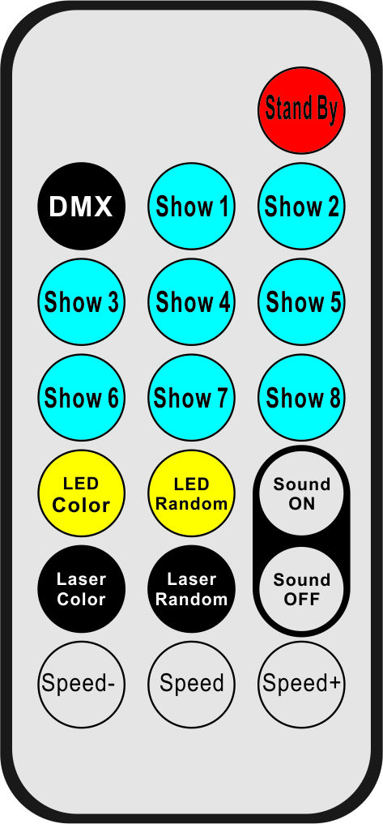
ID | Display | Function
1 | Stand By | Power On/Off
2 | DMX | Hold
3 | Show 1 | Show 1
4 | Show 2 | Show 2
5 | Show 3 | Show 3
6 | Show 4 | Show 4
7 | Show 5 | Show 5
8 | Show 6 | Show 6
9 | Show 7 | Show 7
10 | Show 8 | Show 8
11 | Led Color | LED color Jump
12 | LED Random | LED Color gradual change
13 | Sound on | Sound on
14 | Laser color | Hold
15 | Laser Random | Hold
16 | Sound Off | Sound off
17 | Speed- | Show1-show8 speed increase
18 | Speed | Show1-show8 speed in middle(default)
19 | Speed+ | Show1-show8 speed decrease

Wireless foot controller
5
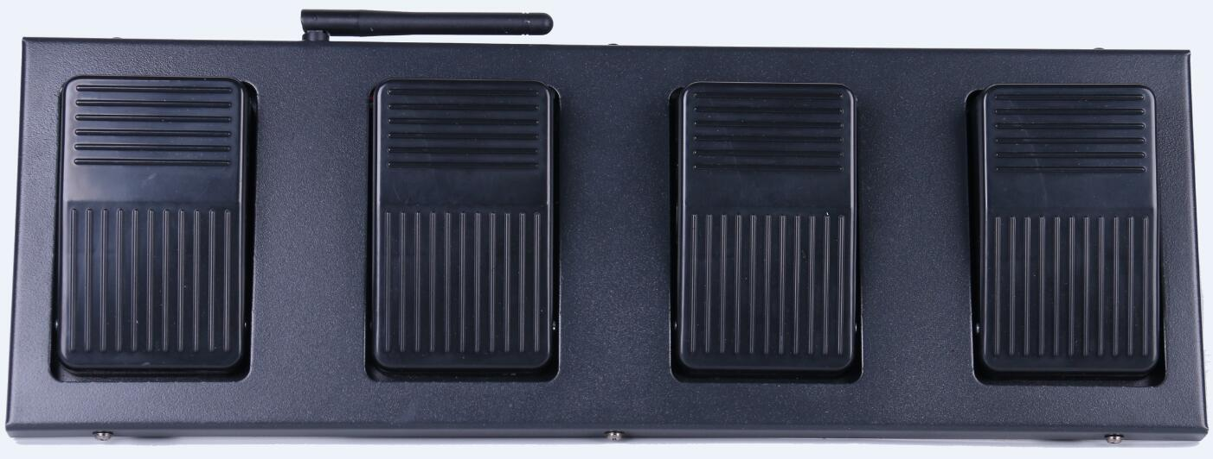
1
2
4
3

ID | Silkscreen | Function
1 | BLACK | Black mode
2 | AUTO | Auto mode
3 | COLOR | Color mode
4 | MUSIC | Sound mode
5 | ON/OFF | Power On/Off

- DMX table
5CH Mode
Channel |  | Value | Function
1CH | Total dimmer | 0-255 | Total dimmer
2CH | Red dimmer | 0-255 | Red dimming
3CH | Green dimmer | 0-255 | Green dimming
4CH | Blue dimmer | 0-255 | Blue dimming
5CH | White dimmer | 0-255 | White dimming

8CH Mode
Channel |  | Value | Function
1CH | Total dimmer | 0-255 | Total dimmer
2CH | Strobe | 0-255 | Strobe from slow to fast
3CH | Red dimmer | 0-255 | Red dimming
4CH | Green dimmer | 0-255 | Green dimming
5CH | Blue dimmer | 0-255 | Blue dimming
6CH | White dimmer | 0-255 | White dimming
7CH | Show mode | 0-9 | No function
7CH | Show mode | 10-99 | Color option
7CH | Show mode | 100-129 | Jumping
7CH | Show mode | 130-159 | Gradual change
7CH | Show mode | 160-189 | Chasing
7CH | Show mode | 190-219 | Sound 1(Gradual +chasing)
7CH | Show mode | 220-249 | Sound 2( Jumping)
7CH | Show mode | 250-255 | Sound 3 (Chasing)
8CH | Speed | 0-255 | Speed from slow to fast
20CH Mode
Channel |  | Value | Function
1CH | Total dimmer | 0-255 | Total dimmer
2CH | Strobe | 0-255 | Strobe from slow to fast
3CH | R1 dimmer | 0-255 | Red1 dimming
4CH | G1 dimmer | 0-255 | Green1 dimming
5CH | B1 dimmer | 0-255 | Blue1 dimming
6CH | W1 dimmer | 0-255 | White1 dimming
7CH | R2 dimmer | 0-255 | Red2 dimming
8CH | G2 dimmer | 0-255 | Green2 dimming
9CH | B2 dimmer | 0-255 | Blue2 dimming
10CH | W2 dimmer | 0-255 | White2 dimming
11CH | R3 dimmer | 0-255 | Red3 dimming
12CH | G3 dimmer | 0-255 | Green3 dimming
13CH | B3 dimmer | 0-255 | Blue3 dimming
14CH | W3 dimmer | 0-255 | White3 dimming
15CH | R4 dimmer | 0-255 | Red4 dimming
16CH | G4 dimmer | 0-255 | Green4 dimming
17CH | B4 dimmer | 0-255 | Blue4 dimming
18CH | W4 dimmer | 0-255 | White4 dimming
19CH | Show mode | 0-9 | No function
19CH | Show mode | 10-99 | Color option
19CH | Show mode | 100-129 | Jumping
19CH | Show mode | 130-159 | Gradual change
19CH | Show mode | 160-189 | Chasing
19CH | Show mode | 190-219 | Sound 1(Gradual +chasing)
19CH | Show mode | 220-249 | Sound 2( Jumping)
19CH | Show mode | 250-255 | Sound 3 (Chasing)
20CH | Speed | 0-255 | Speed from slow to fast

6. DMX-512 control connection

Connect the provided XLR cable to the male 3-pin XLR output of your controller and the other side to the female 3-pin XLR input of the light.You can chain multiple lights together through serial linking, the signal cable should have two core with shielded cable, the signal connectors are with XLR input and output connectors. Please refer to the below diagram:

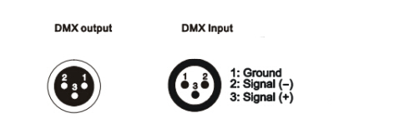
7. DMX address setting
Each fixture must set a specific starting address. When receiving signal, fixture will receive channel control signals of this address from the DMX controller.
For easy to use, the user can set the same address for several fixtures , also can set up a unique address for every device.
If you set the same address for all fixtures, all the fixtures will receive from the same DMX channels signal. All connecting fixtures are jointly controlled, controller can't separate control a device.
If you set a different address for each fixture, each fixture will receive unique signal and can be controlled by DMX controller separately.
This fixture has 20 channels.you should set the starting address of the first unit to 1, the second unit to 21(1*20 + 1), the third unit to 41 (2*20+ 1), and so on.
DMX-512 connection with DMX terminator
If there are many lines or lights, it is recommended to use a DMX terminator to prevent DMX signal corruption, the DMX terminator is an simple XLR plug with a 120 Ω resistor connected between pins 2 and 3,which is then plugged into the output XLR socket of the last fixture in the chain.
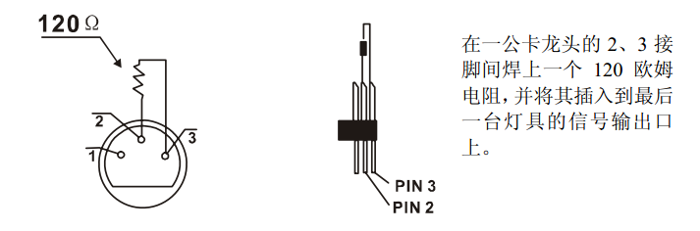
Welding a 120 ohm resistor between 2 and 3 pins male XLR , and insert it into the signal output of the last device
8. Cleaning and maintenance
The following points have to be considered during the inspection:
- . All screws of the device have to be tightly connected and must not be corroded.
- .There must not be any deformation on housings, fixations and installation spots(ceiling, suspension,trussing).
- .Mechanically moving parts like axles,eyes and others must not show any traces of wearing (eg: material abrading or damages)and must not rotate with unbalances.
- .The electric power supply cables must not show any damages,material fatigue(eg: porous cables) or sediments.
5). Please use wet cloth to clean the housing. Glass cleaning liquid is suitable, never use alcohol or solvents!

Further instructions have to be adhered by a skilled installer to prevent any safety problems.

The cooling-fan should be cleaned monthly. The interior of the fixture should be cleaned at least annually using a vacuum-cleaner or an air-jet.

